Intermediate Report on Aging Risk Assessment
1. About dataset:
The `.csv` dataset is designed to predict the aging outcomes of individuals based on various demographic, lifestyle, and health-related features. The dataset classifies individuals into three aging categories: Healthy, At-risk, and Frail. It includes 13 feature columns representing attributes like age, gender, income, and physical activity, which influence aging trajectories
This dataset contains 3456 records and is intended for machine learning tasks, particularly classification and regression. It includes synthetic data on aging prediction, where the outcome variable is derived from several features related to an individual's health and lifestyle. The dataset aims to assist in understanding aging patterns and predicting the likelihood of an individual falling into one of the three aging categories: Healthy, At-risk, or Frail. It provides valuable insights into age-related health outcomes based on demographic and lifestyle factors.
Overall the dataset contained 5 numerical, 8 ordinal, and 2 nominal varables with target being an ordinal variable which allows us to explore methods of strict classification and ordinal regressions. We can apply for example Random Forest methods or choice regressions. Because of abscence of linear relationships between numeric variaables ordinal linear methods would not be considered (Picture 1).
Picture 1. Correlation coefficient assessment
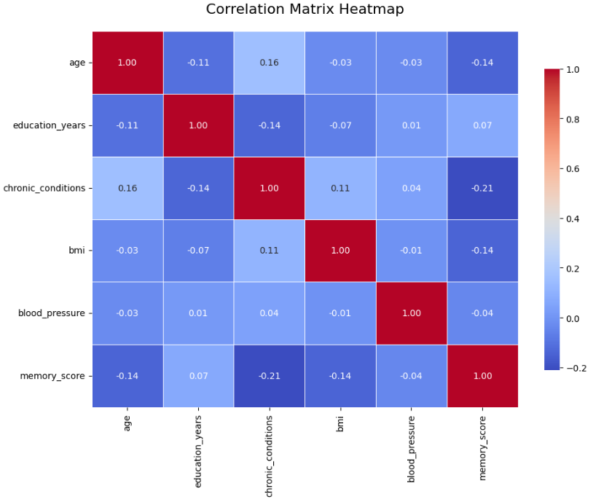
In order to examine additional relationships we directly used catboosting models to examine variable importance in predicting the target. That gave us both measure of importance and prediction model. The catboost is used here because of its fluid categorical columns handling and ani-overfit measures built in. We will try to fit classical `CatBoostClassifier` model.
2. Catboosting result
As we can see AUC metric shows us the best fit at the parameters (Picture 2):
{'depth': 5, 'learning_rate': 0.1, 'l2_leaf_reg': 1}
with nearly perfect fit in 0.99. It may indicate overfitting and that is a limitation of the study, however the model will display the importance correctly.
Picture 2. Grid search probing results
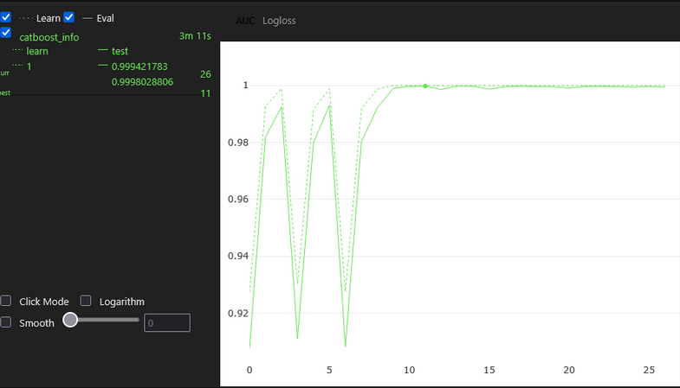
In order to correctly evaluate fitting in the final model we opted to F1 score. The result shows nearly perfetc fit with criterion equals to 0.99 (Picture 3).

Picture 3. Final catboost model performance
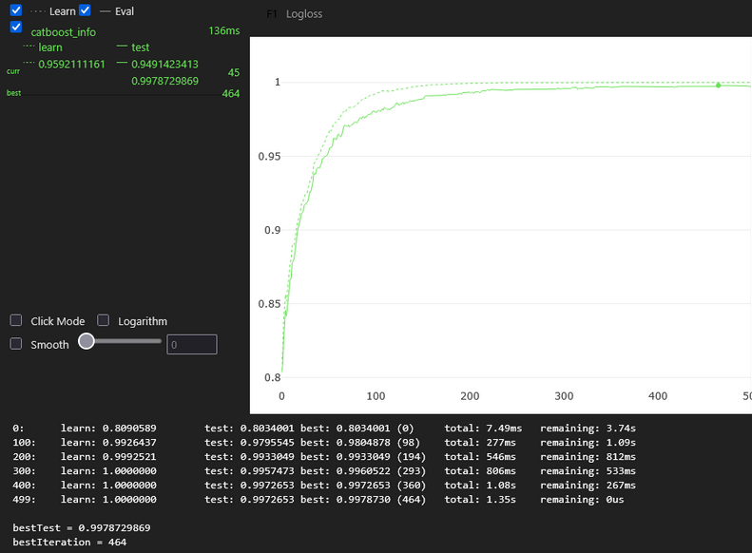
As we can see the most important factors are (above 10) `memory_score`, `education_years`, `chronic_conditions` and `physical_activity`. And the least important are `gemder`, `alcohol_consumption`, `blood_pressure`, and `income_level` (Picture 4).
Picture 4. Catboost Feature Importance
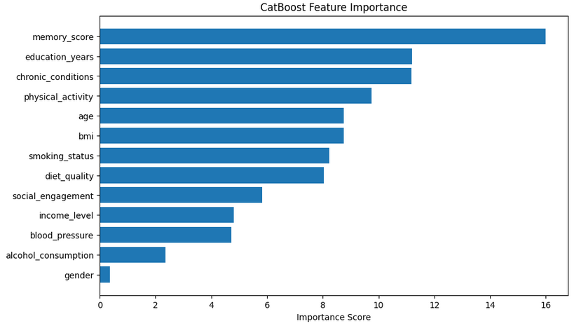
3. Explanatory analysis
We examined differences in `aging_outcome` for different memory scores. In order to do that we employed ANOVA tests (Picture 5):
Picture 5. Anova test results on aging_outcome.
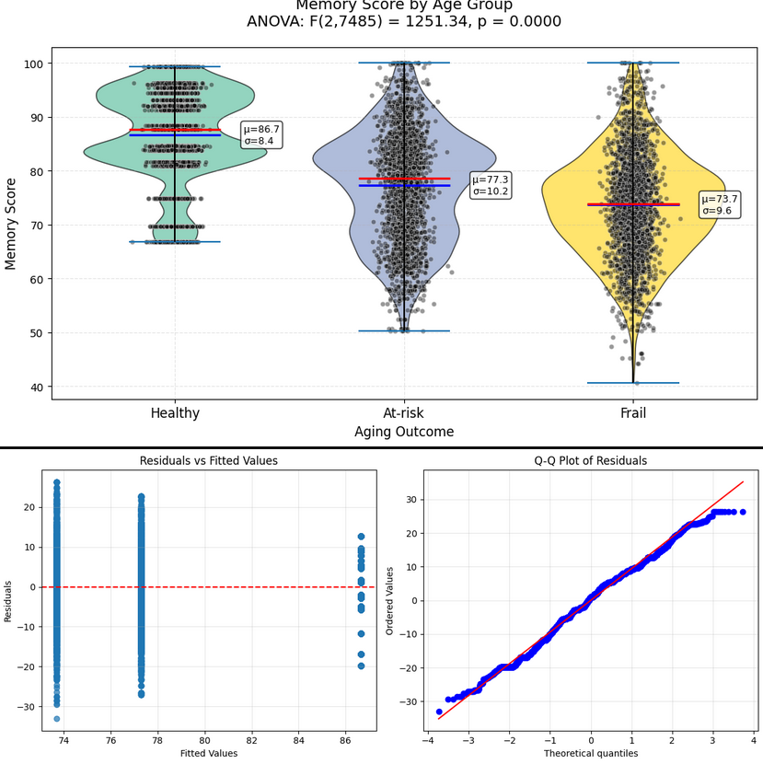
The analysis of variance revealed a statistically significant effect in `aging outcome` category on memory performance. Post-hoc Tukey HSD tests with family-wise error rate control showed that all pairwise comparisons between groups were significant. `Healthy` participants demonstrated the highest mean memory score, `frail` participants performed significantly worse than `at-risk` participants, indicating a graded relationship where increasing frailty corresponds to progressively worse memory function.
Because `At-risk` and `frial` have most normal distributions we can conclude that significant difference between memory scores is very much real.

